# VIRTUAL KEYBOARD

### A MINI PROJECT REPORT

#### Submitted by

#### Group/Team No: G12/T9

#### YASH- 2310991001

#### YASHMEEN-2310991003

#### YATHARTH-2310991004

#### in partial fulfillment for the award of the degree of

## BACHELEOR OF ENGINEERING

***in***

COMPUTER SCIENCE & ENGINEERING



**CHITKARA UNIVERSITY**

**CHANDIGARH-PATIALA NATIONAL HIGHWAY**

**RAJPURA (PATIALA) PUNJAB-140401 (INDIA)**

##### 

##### October 2023

**ABSTRACT**

The virtual keyboard will discuss a new technology in human machine.

Instead of using the mechanical keyboard having moving parts and buttons,

this gadget projects an image of a keyboard for the user’s reference. Using a

camera and digital image processing algorithms the user’s input is detected.

Input to small devices is becoming an increasingly crucial factor in

development for the ever-more powerful embedded market. Speech input

promises to become a feasible alternative to tiny keypads, yet Its limited

reliability, robustness, and flexibility render it unsuitable for certain tasks

and/or environments. This paper surveys technology for alphanumeric input

devices using virtual keyboard projection with a strong focus on touch-

typing.

The virtual keyboard will discuss a new technology in human machine.

Instead of using the mechanical keyboard having moving parts and buttons,

this gadget projects an image of a keyboard for the user’s reference. Using a

camera and digital image processing algorithms the user’s input is detected.

Input to small devices is becoming an increasingly crucial factor in

development for the ever-more powerful embedded market. Speech input

promises to become a feasible alternative to tiny keypads, yet Its limited

reliability, robustness, and flexibility render it unsuitable for certain tasks

and/or environments. This paper surveys technology for alphanumeric input

devices using virtual keyboard projection with a strong focus on touch-

typing.

The virtual keyboard will discuss a new technology in human machine.

Instead of using the mechanical keyboard having moving parts and buttons,

this gadget projects an image of a keyboard for the user’s reference. Using a

camera and digital image processing algorithms the user’s input is detected.

Input to small devices is becoming an increasingly crucial factor in

development for the ever-more powerful embedded market. Speech input

promises to become a feasible alternative to tiny keypads, yet Its limited

reliability, robustness, and flexibility render it unsuitable for certain tasks

and/or environments. This paper surveys technology for alphanumeric input

devices using virtual keyboard projection with a strong focus on touch-

typing.

The virtual keyboard will discuss a new technology in human machine.

Instead of using the mechanical keyboard having moving parts and buttons,

this gadget projects an image of a keyboard for the user’s reference. Using a

camera and digital image processing algorithms the user’s input is detected.

Input to small devices is becoming an increasingly crucial factor in

development for the ever-more powerful embedded market. Speech input

promises to become a feasible alternative to tiny keypads, yet Its limited

reliability, robustness, and flexibility render it unsuitable for certain tasks

and/or environments. This paper surveys technology for alphanumeric input

devices using virtual keyboard projection with a strong focus on touch-

typing.

The virtual keyboard will discuss a new technology in human machine.

Instead of using the mechanical keyboard having moving parts and buttons,

this gadget projects an image of a keyboard for the user’s reference. Using a

camera and digital image processing algorithms the user’s input is detected.

Input to small devices is becoming an increasingly crucial factor in

development for the ever-more powerful embedded market. Speech input

promises to become a feasible alternative to tiny keypads, yet Its limited

reliability, robustness, and flexibility render it unsuitable for certain tasks

and/or environments. This paper surveys technology for alphanumeric input

devices using virtual keyboard projection with a strong focus on touch-

typing.

The virtual keyboard will discuss a new technology in human machine.

Instead of using the mechanical keyboard having moving parts and buttons,

this gadget projects an image of a keyboard for the user’s reference. Using a

camera and digital image processing algorithms the user’s input is detected.

Input to small devices is becoming an increasingly crucial factor in

development for the ever-more powerful embedded market. Speech input

promises to become a feasible alternative to tiny keypads, yet Its limited

reliability, robustness, and flexibility render it unsuitable for certain tasks

and/or environments. This paper surveys technology for alphanumeric input

devices using virtual keyboard projection with a strong focus on touch-

typing.

The virtual keyboard will discuss a new technology in human machine.

Instead of using the mechanical keyboard having moving parts and buttons,

this gadget projects an image of a keyboard for the user’s reference. Using a

camera and digital image processing algorithms the user’s input is detected.

Input to small devices is becoming an increasingly crucial factor in

development for the ever-more powerful embedded market. Speech input

promises to become a feasible alternative to tiny keypads, yet Its limited

reliability, robustness, and flexibility render it unsuitable for certain tasks

and/or environments. This paper surveys technology for alphanumeric input

devices using virtual keyboard projection with a strong focus on touch-

typing.

The virtual keyboard will discuss a new technology in human machine.

Instead of using the mechanical keyboard having moving parts and buttons,

this gadget projects an image of a keyboard for the user’s reference. Using a

camera and digital image processing algorithms the user’s input is detected.

Input to small devices is becoming an increasingly crucial factor in

development for the ever-more powerful embedded market. Speech input

promises to become a feasible alternative to tiny keypads, yet Its limited

reliability, robustness, and flexibility render it unsuitable for certain tasks

and/or environments. This paper surveys technology for alphanumeric input

devices using virtual keyboard projection with a strong focus on touch-

typing.

A virtual keyboard is actually a key-in device, roughly a size of a fountain pen, which uses highly advanced laser technology, to project a full sized keyboard on to a flat surface. Since the invention of computers they had undergone rapid miniaturization. Disks and components grew smaller in size, but only component remained same for decades -its keyboard. Since miniaturization of a traditional keyboard is very difficult we go for virtual keyboard. Here, a camera tracks the finger movements of the typist to get the correct keystroke. A virtual keyboard is a keyboard that a user operates by typing on or within a wireless or optical-detached surface or area rather than by depressing physical keys. Since their invention, computers have undergone rapid miniaturization from being a 'space saver' to 'as tiny as your palm'. Disks and components grew smaller in size, but one component still remained the same for decades - it's the keyboard. Miniaturization of keyboard had proved nightmare for users. Users of PDAs and smart phones are annoyed by the tiny size of the keys. The new innovation Virtual Keyboard uses advanced technologies to project a full-sized computing key-board to any surface. This device has become the solution for mobile computer users who prefer to do touch-typing than cramping over tiny keys. Typing information into mobile devices usually feels about as natural as a linebacker riding a Big Wheel.Virtual Keyboard is a way to eliminate finger cramping. All that's needed to use the keyboard is a flat surface. Using laser technology, a bright red image of a keyboard is projected from a device such as a handheld. Detection technology based on optical recognition allows users to tap the images of the keys so the virtual keyboard behaves like a real one. It's designed to support any typing speed.

The virtual keyboard will discuss a new technology in human machine.

Instead of using the mechanical keyboard having moving parts and buttons,

this gadget projects an image of a keyboard for the user’s reference. Using a

camera and digital image processing algorithms the user’s input is detected.

Input to small devices is becoming an increasingly crucial factor in

development for the ever-more powerful embedded market. Speech input

promises to become a feasible alternative to tiny keypads, yet Its limited

reliability, robustness, and flexibility render it unsuitable for certain tasks

and/or environments. This paper surveys technology for alphanumeric input

devices using virtual keyboard projection with a strong focus on touch-

typing.

The virtual keyboard will discuss a new technology in human machine.

Instead of using the mechanical keyboard having moving parts and buttons,

this gadget projects an image of a keyboard for the user’s reference. Using a

camera and digital image processing algorithms the user’s input is detected.

Input to small devices is becoming an increasingly crucial factor in

development for the ever-more powerful embedded market. Speech input

promises to become a feasible alternative to tiny keypads, yet Its limited

reliability, robustness, and flexibility render it unsuitable for certain tasks

and/or environments. This paper surveys technology for alphanumeric input

devices using virtual keyboard projection with a strong focus on touch-

typing.

The virtual keyboard will discuss a new technology in human machine.

Instead of using the mechanical keyboard having moving parts and buttons,

this gadget projects an image of a keyboard for the user’s reference. Using a

camera and digital image processing algorithms the user’s input is detected.

Input to small devices is becoming an increasingly crucial factor in

development for the ever-more powerful embedded market. Speech input

promises to become a feasible alternative to tiny keypads, yet Its limited

reliability, robustness, and flexibility render it unsuitable for certain tasks

and/or environments. This paper surveys technology for alphanumeric input

devices using virtual keyboard projection with a strong focus on touch-

typing.

The virtual keyboard will discuss a new technology in human machine.

Instead of using the mechanical keyboard having moving parts and buttons,

this gadget projects an image of a keyboard for the user’s reference. Using a

camera and digital image processing algorithms the user’s input is detected.

Input to small devices is becoming an increasingly crucial factor in

development for the ever-more powerful embedded market. Speech input

promises to become a feasible alternative to tiny keypads, yet Its limited

reliability, robustness, and flexibility render it unsuitable for certain tasks

and/or environments. This paper surveys technology for alphanumeric input

devices using virtual keyboard projection with a strong focus on touch-

typing.

The virtual keyboard will discuss a new technology in human machine.

Instead of using the mechanical keyboard having moving parts and buttons,

this gadget projects an image of a keyboard for the user’s reference. Using a

camera and digital image processing algorithms the user’s input is detected.

Input to small devices is becoming an increasingly crucial factor in

development for the ever-more powerful embedded market. Speech input

promises to become a feasible alternative to tiny keypads, yet Its limited

reliability, robustness, and flexibility render it unsuitable for certain tasks

and/or environments. This paper surveys technology for alphanumeric input

devices using virtual keyboard projection with a strong focus on touch-

typing.

The virtual keyboard will discuss a new technology in human machine. Instead of using a mechanical keyboard having moving parts and buttons, this gadget projects an image of keyboard for the user’s reference. Using a camera and digital image processing algorithms the user’s input is detected. Input to small devices is becoming an increasingly crucial factor in development for the ever-more powerful embedded market.

**TABLE OF CONTENTS**

|  |  |  |
| --- | --- | --- |
| **Sr. NO.** | **SECTION** | **PAGE NO.** |
| **1)** | **INTRODUCTION** | **4** |
| **2)** | **PROBLEM STATEMENT** | **5** |
| **3)** | **TECHNICAL DETAILS** | **6** |
| **4)** | **KEY FEATURES** | **7** |
| **5)** | **PROJECT ADVANTAGES** | **8-9** |
| **6)** | **BONUS FEATURES** | **10** |
| **7)** | **RESULTS** | **11-17** |
| **8)** | **CONCLUSION WITH FUTURE SCOPE** | **18** |

**INTRODUCTION**

An alternative to a physical [keyboard](https://www.computerhope.com/jargon/k/keyboard.htm), a virtual keyboard is a software-based keyboard used with [touch screen](https://www.computerhope.com/jargon/t/toucscre.htm) devices. The keyboard is a digital representation of a [QWERTY](https://www.computerhope.com/jargon/q/qwerty.htm) keyboard that appears on the screen when text input is required by the application. The user can then tap the virtual keys for typing words.

Virtual keyboards often include multiple pages of [characters](https://www.computerhope.com/jargon/c/charact.htm), containing [letters](https://www.computerhope.com/jargon/l/letter.htm), [punctuation](https://www.computerhope.com/jargon/p/punctuation.htm), [numbers](https://www.computerhope.com/jargon/n/number.htm), and [symbols](https://www.computerhope.com/jargon/s/symbol.htm). Depending on the device's operating system, there may also be options to insert [emojis](https://www.computerhope.com/jargon/e/emoji.htm), stickers, or [animated GIFs](https://www.computerhope.com/jargon/g/gif89a.htm).

Virtual keyboards are featured on [smartphones](https://www.computerhope.com/jargon/s/smartphone.htm), [tablets](https://www.computerhope.com/jargon/t/tablet.htm), and other portable devices that do not require the constant use of a physical keyboard. Most developers have created [proprietary](https://www.computerhope.com/jargon/p/propriet.htm) virtual keyboards for their devices. However, the default virtual keyboard can often be replaced with [third-party](https://www.computerhope.com/jargon/t/thirpart.htm) virtual keyboard [apps](https://www.computerhope.com/jargon/a/app.htm), available for download or purchase on the device's [app store](https://www.computerhope.com/jargon/a/app-store.htm).

**The virtual keyboard was initially designed to provide an on-screen instance of the keyboard for users with disabilities or a malfunctioning physical keyboard. User simply point and click (or on a touchscreen, touch) the visible keys.**

A virtual keyboard is software that is used to emulate a standard keyboard. A picture of a keyboard is displayed on a computer screen and the user points and clicks on the pictures of keys to enter text. [Switches](https://www.washington.edu/doit/how-can-switches-be-used-people-who-cannot-operate-standard-keyboard-or-mouse) activated in a wide variety of ways make use of the most appropriate muscles for the individual user. Virtual keyboards allow computer use by people with significant mobility impairments. Some virtual keyboards incorporate [word prediction](https://www.washington.edu/doit/what-does-word-prediction-software-do) to increase entry speed.

###### **TEAM INTRODUCTION**

This Project is allocated to **Team no. 08** of **Group 12**. This team has 3 members-

###### YASH – 2310991001

YASHMEEN- 2310991003

###### YATHARTH-2310991004

**PROBLEM STATEMENT**

A virtual keyboard is a software-based interface that allows users to input characters and commands without the need for a physical keyboard. The problem statement for a virtual keyboard can encompass various aspects depending on the specific goals and requirements of the project. Here are some key elements that might be considered in a problem statement for a virtual keyboard:

* **User Interface Design:**

Define the target platform(s) for the virtual keyboard (e.g., desktop, mobile, tablet).

Specify the design principles for the user interface, including layout, key size, and visual style.

Consider accessibility features to ensure usability for all users, including those with disabilities.

* **Functionality:**

Outline the basic functionality of the virtual keyboard, such as keypress recognition, key highlighting, and support for different keyboard layouts (e.g., QWERTY, AZERTY, Dvorak).

Specify any additional features, such as predictive text, autocorrect, or gesture-based input.

* **Compatibility:**

Address compatibility issues with various operating systems (Windows, macOS, Linux, Android, iOS) and applications.

Ensure seamless integration with other software and devices, including support for external physical keyboards.

* **Scalability and Updates:**

Consider scalability for future updates and improvements.

Implement a mechanism for easy updates and patches to address emerging issues and add new features.

* **Security:**

Identify and address potential security concerns, such as keystroke logging and data encryption.

Implement measures to prevent unauthorized access to sensitive information entered via the virtual keyboard.

* **Testing and Quality Assurance:**

Define a comprehensive testing plan to identify and resolve bugs and usability issues.

Conduct usability testing with a diverse group of users to gather feedback and make improvements.

**TECHNICAL DETAILS**

* **DEVICE SPECIFICATION**

Device name: LAPTOP-R29E214C

Processor: 12th Gen Intel(R) Core(TM) i5-12450H 2.00 GHz

Installed RAM: 8.00 GB (7.68 GB usable)

Device ID: ACC09776-1E48-4319-8E6C-EF5506F0C128

Product ID: 00356-24684-51446-AAOEM

System type: 64-bit operating system, x64-based processor

Pen and touch: No pen or touch input is available for this display

* **WINDOW SPECIFICATION**

Edition Windows 11 Home Single Language

Version 22H2

Installed on ‎12-‎08-‎2023

OS build 22621.2715

Experience Windows Feature Experience Pack 1000.22677.1000.0

* **SOFTWARES USED:-**

VS CODE

MICROSOFT POWER POINT

MICROSOFT WORD

* **PROGRAMMING LANGUAGES: -**

HTML

CSS

BOOTSTRAP

**KEY FEATURES OF VIRTUAL KEYBOARD**

**Some Key Features Of This Project:**

**ACCESSIBLE AND CONVENIENT WAY OF TYPING:**

Virtual keyboards do not require users to press any physical keys. Instead, they offer a more accessible and convenient way of typing and interacting with devices through touchscreens, styluses, or other pointing devices.

* **VERSATILITY AND EASE TO USE:**

Virtual keyboards have become increasingly popular due to their versatility and ease of use. They serve as an alternative input method for people who may struggle with traditional keyboards, allowing them to enter text and navigate through computer systems more easily. A picture of a keyboard is displayed on a computer screen and the user clicks on the pictures of keys to enter text.

* **ON-SCREEN KEYS:**

Virtual keyboards have keys displayed on a screen, just like a regular keyboard. You tap or click on these keys to input characters.

* **TOUCH OR CLICK INPUT:**

You can use your fingers (on touchscreens) or a mouse to interact with the virtual keys instead of pressing physical buttons.

* **CUSTOMIZABLE LAYOUTS:**

You can often customize the arrangement and appearance of keys based on your preferences or language needs.

* **LANGUAGE OPTIONS:**

Virtual keyboards support multiple languages, allowing you to easily switch between different language layouts.

* **ACCESSIBILITY FEATURES:**

They may have features to assist users with disabilities, such as larger keys, voice input, or keyboard shortcuts.

* **COMPATIBILITY:**

Virtual keyboards work on various devices like computers, tablets, and smartphones, making them versatile**.**

* **INTEGRATION WITH OTHER APPS:**

Virtual keyboards seamlessly integrate with other applications, allowing you to use them in messaging, word processing, and more.

* **USER-FRIENDLY DESIGN:**

The design aims for simplicity and ease of use, ensuring that users can quickly understand and use the virtual keyboard.

**PROJECT ADVANTAGES**

Virtual keyboards offer several advantages, making them a popular choice for various devices and applications. Here are some key advantages:

* **SPACE EFFICIENCY:**

Virtual keyboards eliminate the need for a physical keyboard, saving space on devices with limited real estate, such as smartphones and tablets.

* **ADAPTABILITY:**

Virtual keyboards can adapt to different languages and keyboard layouts, allowing users to switch between them easily.

* **CUSTOMIZATION:**Users can often customize the appearance and layout of virtual keyboards to suit their preferences, including themes and key arrangements.
* **MULTIFUNCTIONALITY:**

Virtual keyboards can serve multiple functions beyond typing, such as providing shortcuts, gesture input, and access to special characters or emojis**.**

* **ACCESSIBILITY FEATURES:**

Many virtual keyboards come with features like larger key options, voice input, and predictive text, making them more accessible for users with disabilities.

* **PORTABILITY:**Virtual keyboards contribute to the portability of devices by eliminating the need for a physical keyboard, making them more convenient for on-the-go use.
* **TOUCHSCREEN INTERACTION:**

Virtual keyboards take advantage of touchscreen technology, allowing users to interact with the keys using touch gestures, making the user experience more intuitive.

* **LANGUAGE SUPPORT:**

Virtual keyboards can support a wide range of languages, enabling users to type in different languages without the need for separate physical keyboards.

* **COST SAVINGS:**

For devices like smartphones and tablets, virtual keyboards contribute to cost savings by eliminating the need for physical keyboard components.

* **EASE OF UPDATES:**

Software updates for virtual keyboards are relatively easy to implement, allowing for improvements, bug fixes, and the addition of new features without requiring hardware changes.

* **INTEGRATION WITH TOUCH AND PEN INPUT:**

Virtual keyboards seamlessly integrate with touch and pen input methods, providing a cohesive user experience on devices that support these input options.

* **Reduced Maintenance:**

Without physical keys, there are fewer components that can wear out or break, reducing the need for maintenance or repairs.

* **Security Measures:**

Virtual keyboards can incorporate security features like encryption and secure input methods to protect user data from unauthorized access.

**BONUS FEATURES**

Virtual Keyboards often come with bonus features that enhance user experience and productivity. Here are some bonus features commonly found in virtual keyboards:

* **GESTURE TYPING:**

Users can swipe across the virtual keys to input words, providing a faster alternative to tapping individual keys.

* **VOICE INPUT:**

Integration with voice recognition allows users to speak instead of type, converting spoken words into text.

* **CLIPBOARD HISTORY:**

A feature that keeps a history of copied text, allowing users to easily paste multiple items without having to recopy them.

* **ONE-HANDED MODE:**

A layout option that condenses the keyboard for easier one-handed use, especially on larger screens.

* **SPLIT KEYBOARD:**

A feature that divides the keyboard into two halves, making it easier to type with thumbs on larger devices.

* **TRANSLATOR INTEGRATION:**

Integration with translation services, allowing users to translate text directly within the keyboard interface.

* **MATH SYMBOLS AND EQUATIONS:**

Specialized keys or modes for entering mathematical symbols and equations easily.

* **QUICK ACCESS TO SETTINGS:**

Direct shortcuts to keyboard settings, allowing users to customize features without navigating through device settings.

* **BRAILLE INPUT SUPPORT:**

Virtual keyboards with support for Braille input, catering to users with visual impairments who are proficient in Braille.

* **DYNAMIC KEY RESIZING:**

Keys that dynamically resize based on typing patterns, making frequently used keys larger for improved accuracy.

* **SMART CAPITALIZATION:**

Automatic capitalization of the first letter of sentences or certain words for improved writing conventions.

**RESULT**

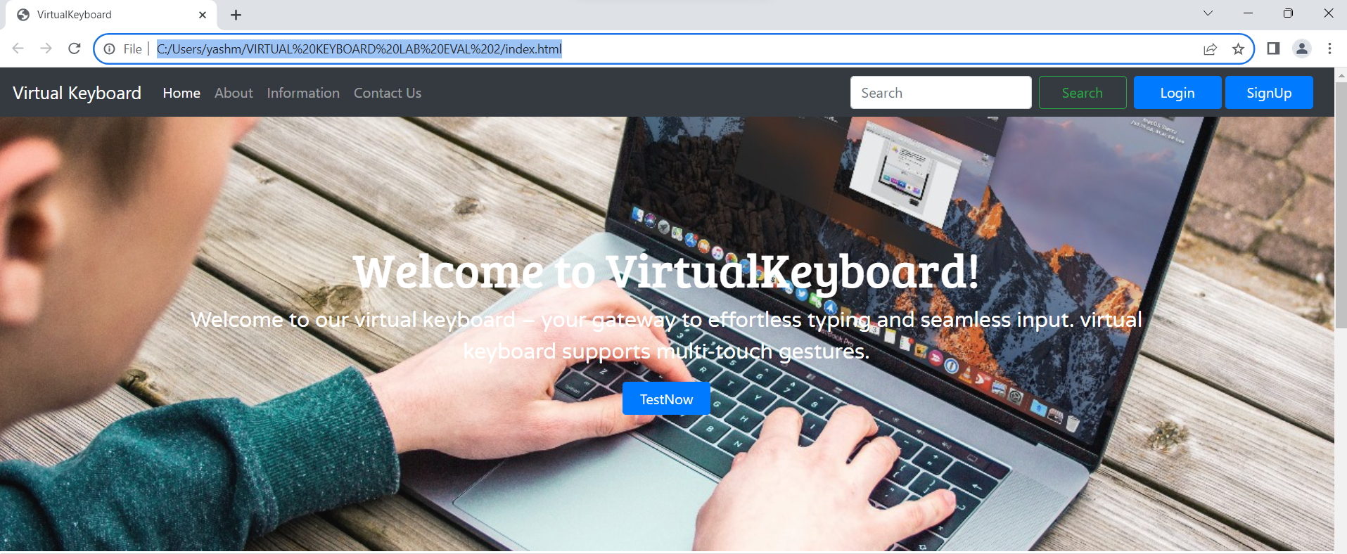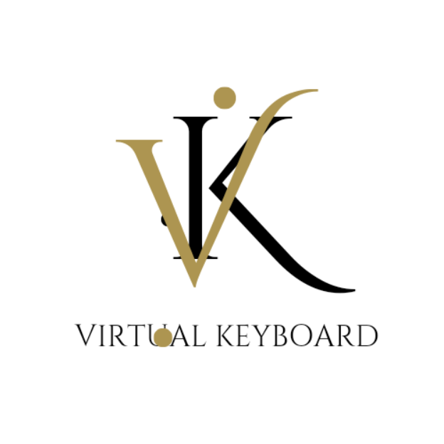

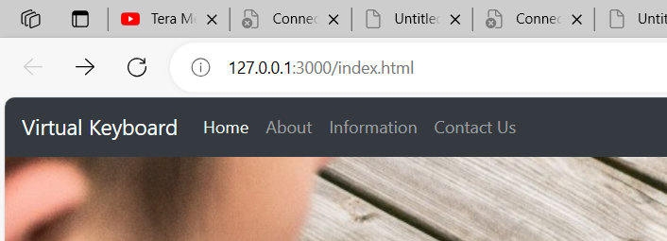

1. 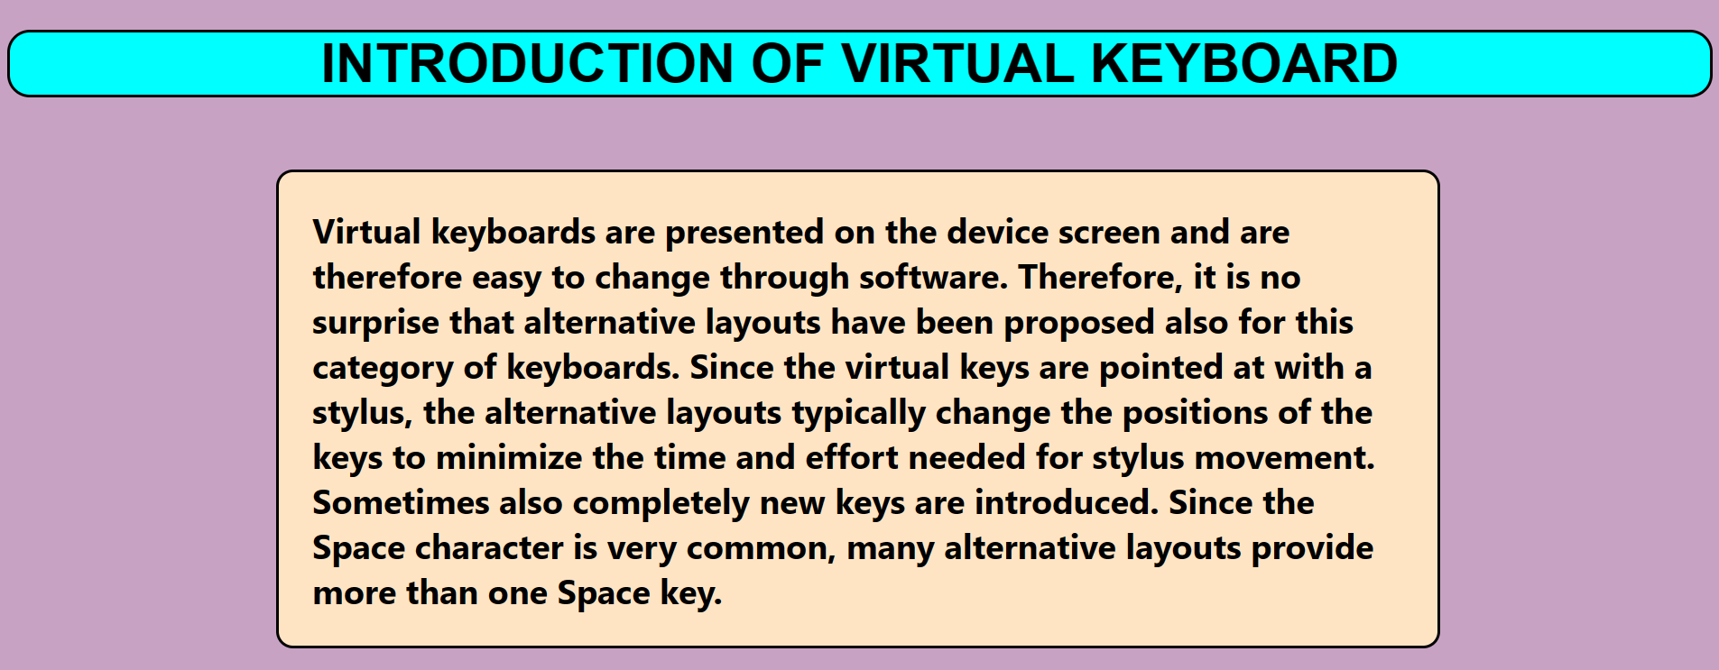**AFTER CLICKING HOME**

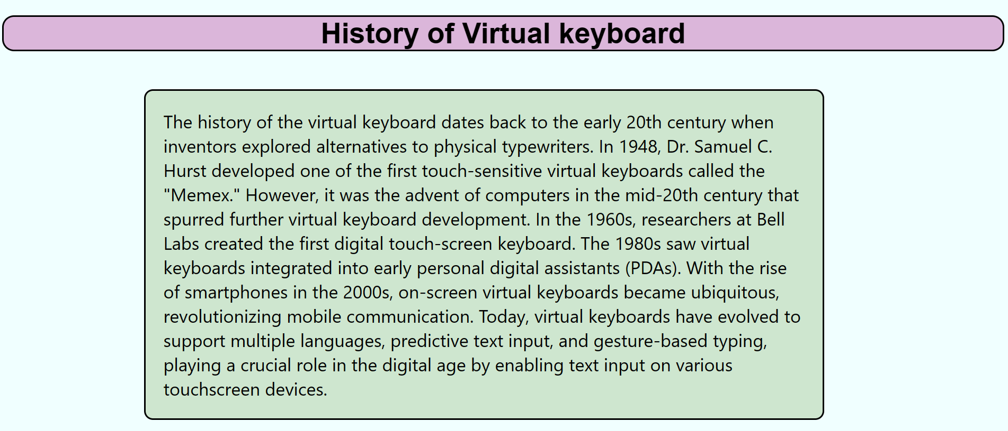**2)AFTER CLICKING ABOUT**

**3)AFTER CLICKING INFORMATON**

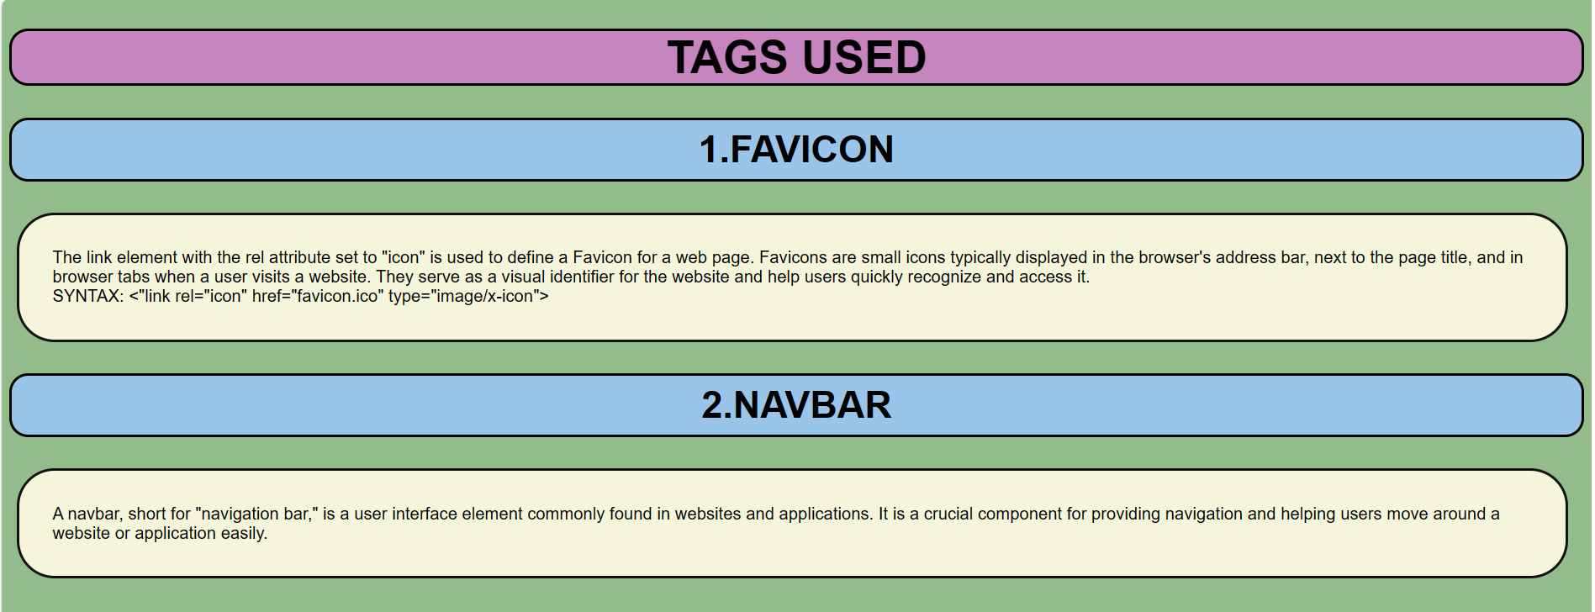

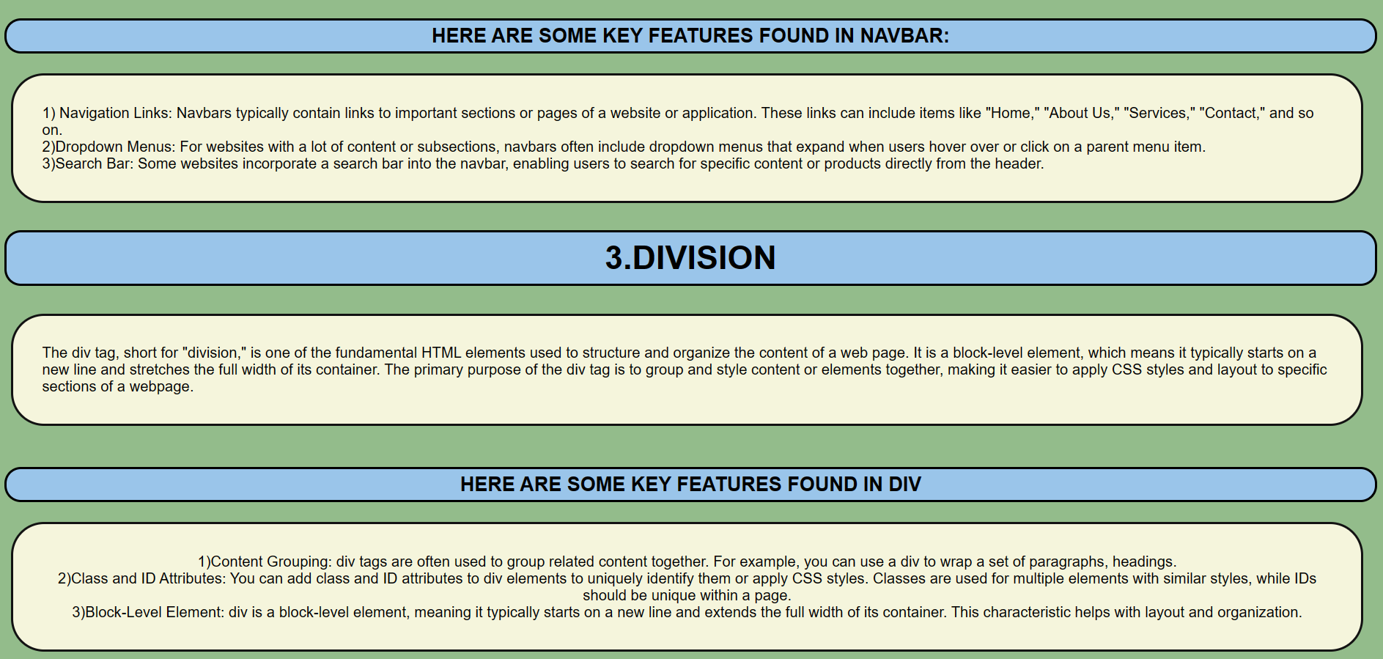

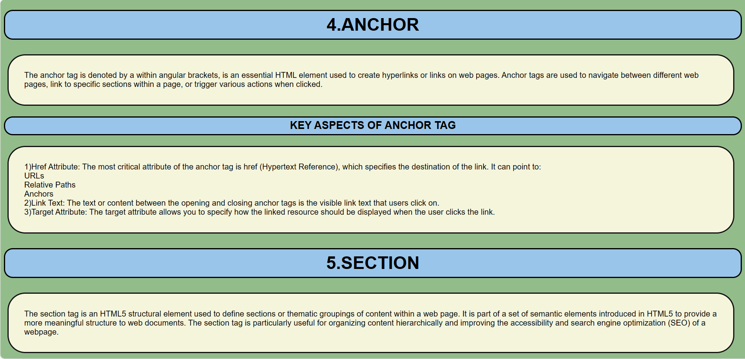

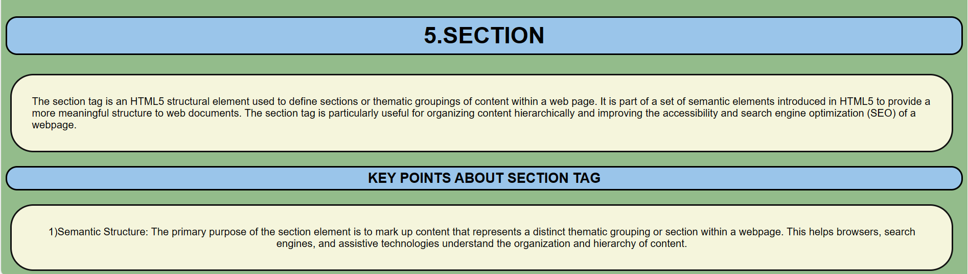



**AFTER CLICKING LOG IN BUTTOM**

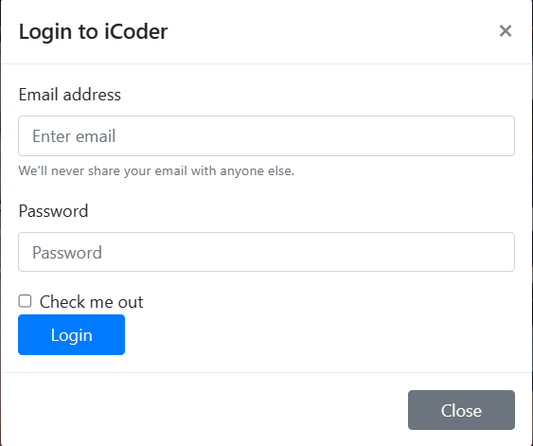

**AFTER CLICKING SIGN UP BUTTON**

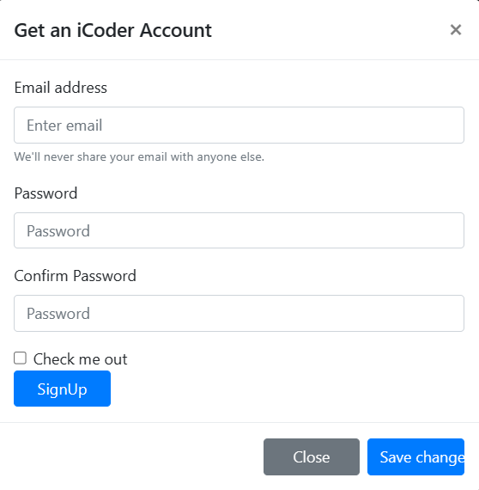

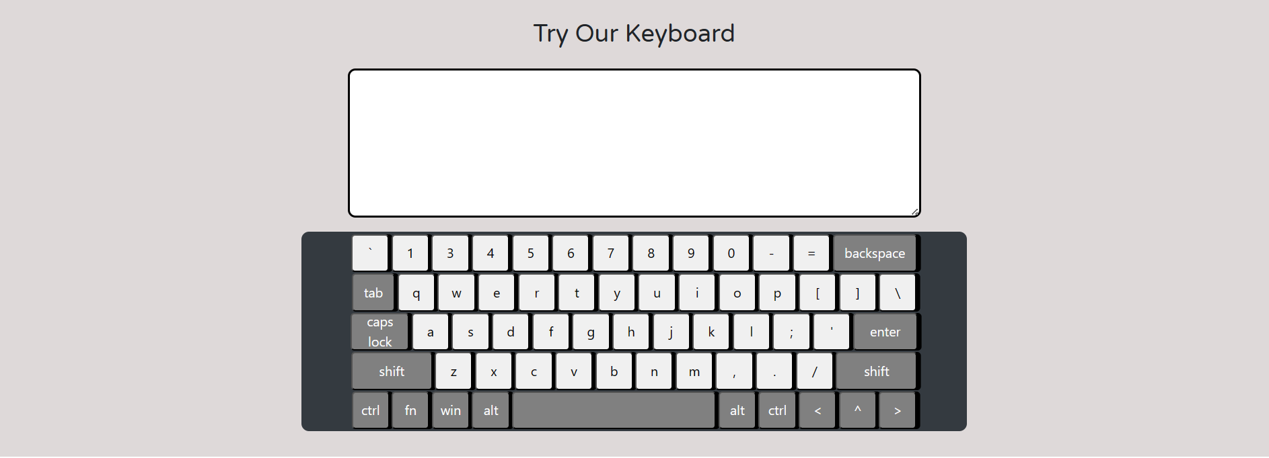**VIRTUAL KEYBOARD MADE BY US**

**FUTURE SCOPE**

The future scope of virtual keyboards is likely to evolve in response to advancements in technology and changes in user needs.

* **ENHANCED AI AND PREDICTIVE INPUT:**

Integration of advanced artificial intelligence (AI) algorithms to provide even more accurate and context-aware predictive text suggestions, reducing the need for manual typing.

* **NATURAL LANGUAGE PROCESSING (NLP):**

Incorporation of NLP technologies to enable virtual keyboards to better understand and interpret natural language, leading to more intuitive and human-like interactions.

* **GESTURE AND MOTION INPUT:**

Expansion of gesture and motion-based input methods, allowing users to control virtual keyboards through hand movements or gestures in the air.

* **AUGMENTED REALITY (AR) INTEGRATION:**

Integration of virtual keyboards into augmented reality environments, enabling users to type in virtual spaces using AR glasses or devices.

* **BIOMETRIC AUTHENTICATION:**

Integration of biometric authentication methods, such as fingerprint or facial recognition, to enhance the security of virtual keyboard inputs.

* **EMOTION RECOGNITION:**

Implementation of emotion recognition technology to analyze user input and adjust suggestions or responses based on the emotional context of the communication.

* **QUANTUM COMPUTING CONSIDERATIONS:**

Exploration of how virtual keyboards can leverage the capabilities of quantum computing for faster and more efficient processing, especially in handling complex language models.

* **CONTEXTUAL AWARENESS:**

Further development of contextual awareness, where virtual keyboards understand and adapt to the user's environment, adjusting the keyboard layout or suggestions accordingly.

* **BLOCKCHAIN INTEGRATION FOR SECURITY:**

Integration of blockchain technology to enhance the security and privacy of virtual keyboard inputs, ensuring secure and tamper-resistant communication.

* **3D VIRTUAL KEYBOARDS:**

Exploration of three-dimensional virtual keyboards that take advantage of spatial computing, allowing users to interact with keys in a three-dimensional space.

**CONCLUSION**

The virtual keyboard concept demonstrated in our project is not only technically feasible, but also has enormous market potential. As our aim for building the gadget was only to test its technical feasibility, there are some drawbacks to the device which need to be overcome before its true potential can be realized.

**REFERENCES**

1. Seminarsonly.com:

<https://www.seminarsonly.com/computer%20science/Virtual%20keyboard.php>

1. UNIVERSITY OF WASHINGTON:

<https://www.washington.edu/accesscomputing/what-virtual-keyboard>

1. IJSER:

<https://www.ijser.org/paper/Virtual-Keyboard-2014.html>

1. WIKIPEDIA:

<https://en.wikipedia.org/wiki/Virtual_keyboard>

1. SLIDE SHARE:

<https://www.slideshare.net/siddhantranjan/virtual-keyboard-36251213>

1. DiVA PORTAL:

<https://www.divaportal.org/smash/get/diva2:669114/FULLTEXT01.pdf>

